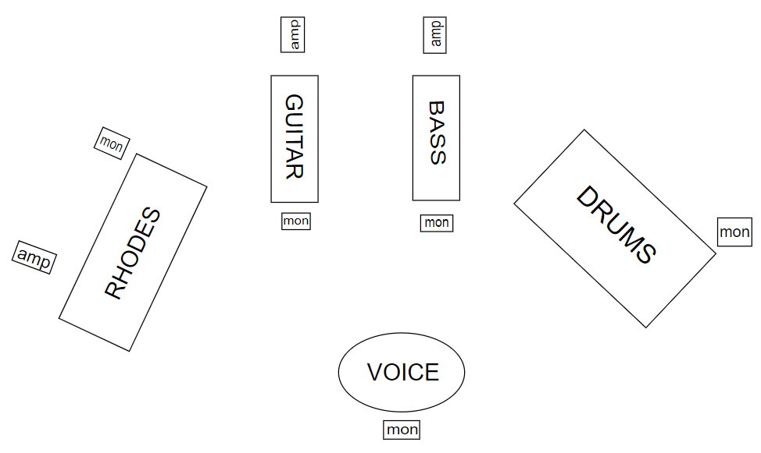

MARTA POPOVICI & ON THE FLY - TECH RIDER

MONITORS
5 MONITORS with independent mixes and volumes

BACKLINE:
DRUMS
- 20" bass drum (with a pedal)
- 14" snare with a coated snare head (with a stand)
- 12" tom, 14" floor tom (each with a stand)
- 3 cymbal stands
- high-hat
- drum chair (a model that uses a spiral for height adjustment)
- a drum carpet
The drummer would like to bring his own cymbals. However, this depends on transportation conditions.

PIANO
Please let us know about the availability of an Acoustic Grand Piano or of a Fender Rhodes electric piano (including an amp like Fender Twin Reverb or something similar, an amp used for guitar, normally, but not Marshall brand).

GUITAR
Please provide an amplifier, preferably Fender. If that is not possible, Marshall.

BASS
Please provide a bass amplifier. Preferred brands are Gallien-Krueger, Ampeg, MarkBass.

VOCALS
The singer will use her own microphone, Shure Beta 87A.
Please provide a table suitable for a small pedalboard on which the effect pedals can be placed.

